**HUYE CAMPUS**

**COLLEGE OF SCIENCE AND TECHNOLOGY**

**DEPARTMENT OF COMPUTER AND SOFTWARE ENGINEEERING**

**MODULE: WEB TECHNOLOGY**

**LECTURER: MR HITIMANA ERIC**

**NAME: MUGABE GILBERT**

**DATE: 02 AUGUST 2022**

**REGNO: 221013757**

**YEAR OF STUDY: TWO**

**PROJECT NAME: IGIFU WEBSITE**

Table of contents



Table of Figures.................................................................................. 2

List of Abbreviations ............................................................................................ 2

**Chapter 1. Introduction** ................................................................................................. 3

* 1. problem summary .......................................................................................................
  2. problem statement .......................................................................................................

1.3. Objectives of your project........................................................................................ 4

1.4. importance of project. ....................................................................................................... 5

**Chapter 2. METHODOLOGIES AND METHODS** ........................................................... 5

2.1. Data collection methodology ............................................................................................................................ 5

2.2 Functional Requirements of project. ................................................................................................................ 9

**Chapter 3. SYSTEM ANALYSIS AND DESIGN**.........................................10

3.1. Requirement specifications......................................................10

3.2. Functional requirement ................................................................................10

3.3. Data requirement.................................................................................................10

3.4. Security requirement.................................................................................................10

3.5. Non-functional requirement.........................................................................................10

3.6. System Design................................................................................................10

**Chapter 4. SYSTEM IMPLEMENTATION**.........................................15

4.1. Landing page......................................................15

4.2. Login page......................................................15

4.3. And so on at least 5 pages of you ......................................................15

**Chapter 5. CONCLUSION**.........................................20

**Chapter 6. RECOMMANDATION**.........................................25

**Chapter 7. APPENDIX**.........................................30

**1.INTRODUCTION**

1.1 Project summary

This project is designed to be used by customs/student to help them know how they can order foods and drinks online without going to the restaurants

1.2 problem statement

* Inventory Shrinkage and Waste.
* The Need to Reduce Face-to-Face Contact Between Customers and Staff
* Heavy Labor Costs.
* High Employee Turnover.
* Poor Customer Experience.

1.3 Objective of this project

* Increase sales and profits.
* Keep the restaurant profitable at all times.
* Maximize the sustainability and efficiency of the restaurant.

1.4 Project Rational

* This project will improve customer experience.
* This project will increase transaction amounts.
* This project will be easier to place/make large orders.
* Fewer abandoned orders

2.**METHODOLOGIES**

2.1 Data collection methodology

My friend of mine lost his receipts the restaurant gave to him and he spent all day without taking his meal and he was already paid for that food that’s where my idea came up of making project that will help people ordering foods online and how that project will help them the restaurant’s owners on how they can keep credentials of their customs without giving receipts to the customers cause those receipts can be lost accidentally.

2.2 Tools to be used

2.2.1. Hardware tools

* Computer
* Pos
* Smartphones

2.2.2. Software tools

* Xammp control panel
* Visual studio code
* Figma
* Canva

3.**System analysis and Design**

3.1. Requirement specifications

3.1.1 Functions requirement

This project will require users to register themselves first in registration module and after registration they will have to log in so that restaurant owners would know their customs in their database

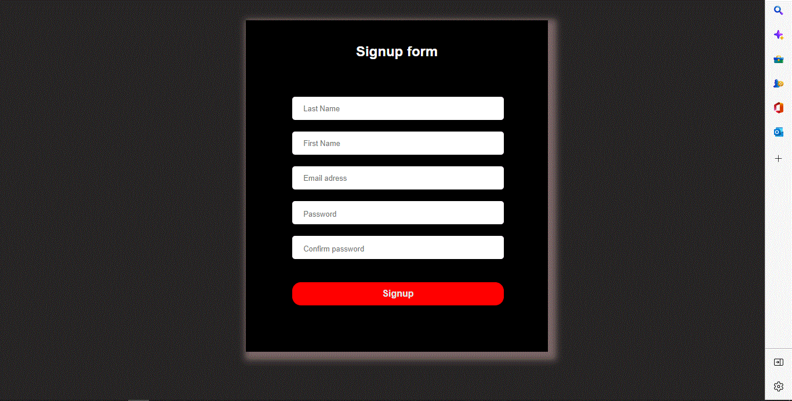

3.1.1 Data requirement

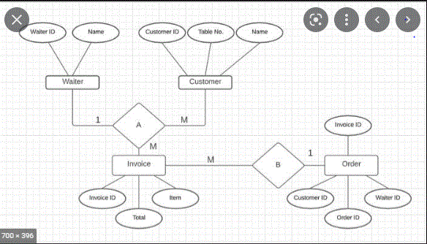

3.1.2 User requirement

The main actors of my project will be costumers/student they will have to be given authorization by restaurant’s owners and they should have encrypted password

3.1.3 Security requirement

Every user of this project should have encrypted password as I stated above and will also have the email in order to be given access everything

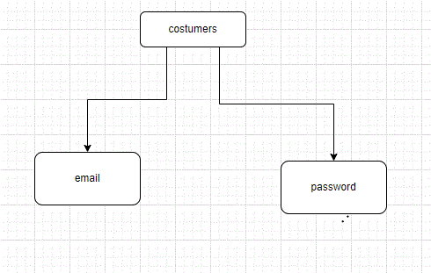

3.1.4 Non-functional requirement

The performance of this project will have high performance rate when executing user’s input should be able to provide feedback and response.

Ease of use: considered level of knowledge

3.1.5 System design

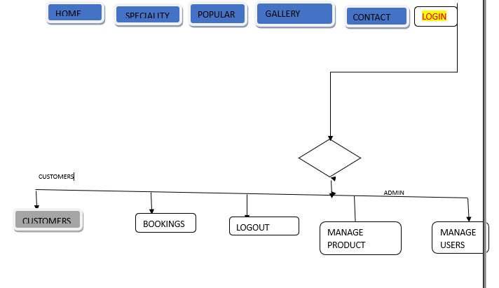

4.**System Implementation**

4.1 Landing page

This picture detail the landing page of my project , from this page you can see the button order where you can order everything you want but you will have to register first.

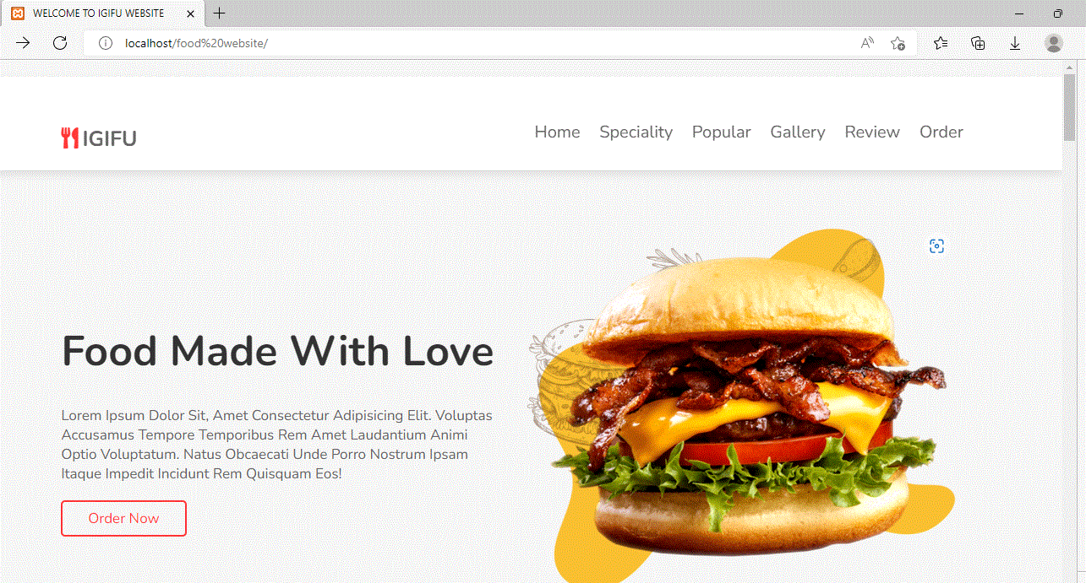

4.2 Login page

This page detail the login process of the proposed project. This will require the user to enter his/her email and password.

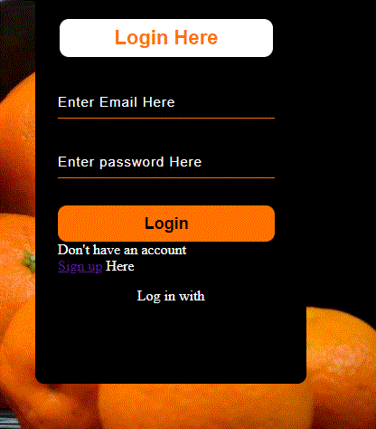

4.3 mysql database

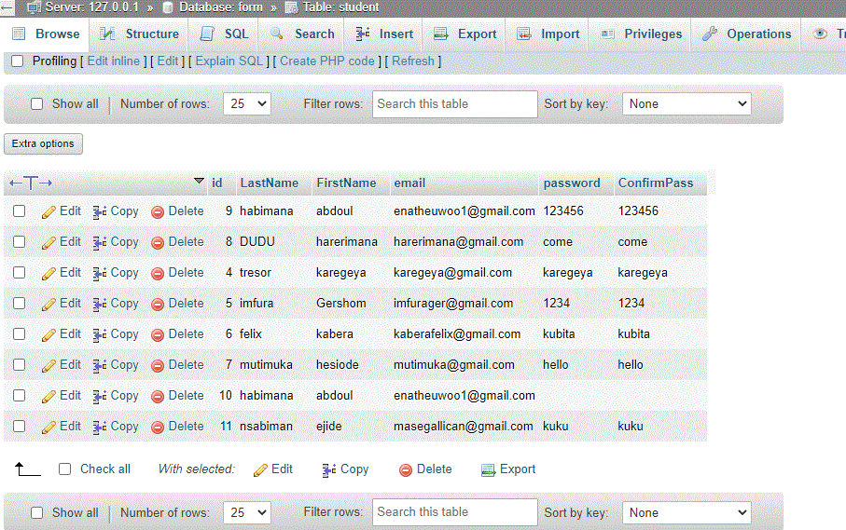

4.4 User registration

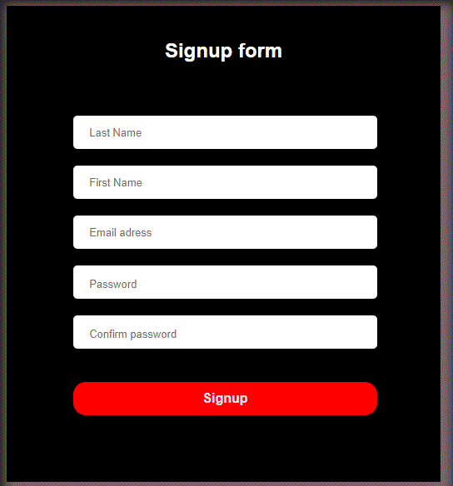

5.**Conclusion**

So, as conclusion, food is one of the basic necessities of human. Therefore, there should not be such problem that can cause serious health issues to protect consumer rights. A wide variety of scientific techniques have been developed to protect consumers and to screen for adulteration in food.

6.**Recommendation**

Having good restaurant reviews is **crucial** these days. It is not just making our decision to pick one easier, it is also helping the restaurant to be more successful. When the online [review](https://en.wikipedia.org/wiki/Review) system was introduced, restaurants and other businesses as well improved their quality and service in order to gain more positive feedbacks from guests.

What do you recommend to:

* Other restaurant
* Restaurant companies doing food reservation.

7.**Appendix**

<https://gilbert-2.github.io/foodwebsite/>